WORLD NEWS
08/13/2018 09:27 am ET

This Small Caribbean Island Is Waging A Big War Against Plastic

https://www.huffingtonpost.com/entry/dominica-plastic-styrofoam-ban_us_5b715ed4e4b0530743cb7bce

Dominica’s government plans to ban plastic and styrofoam food containers and utensils by 2019.
By Dominique Mosbergen
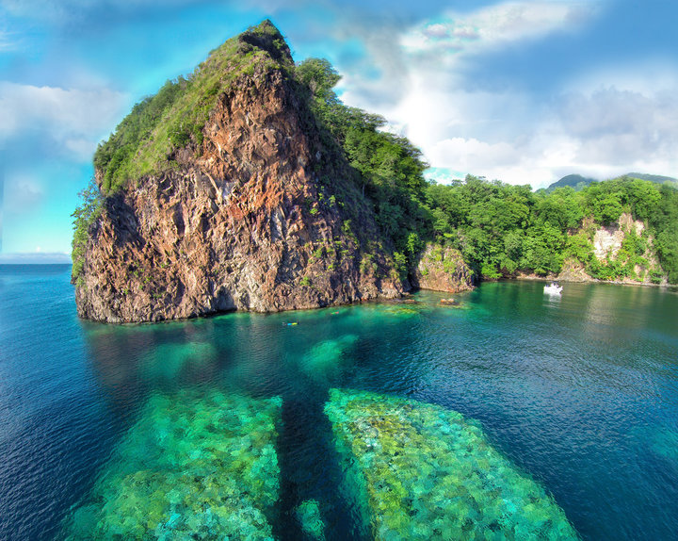
Derek Galon/Getty Images Dominica is a natural paradise. And its government says it wants to keep it that way.
The small Caribbean island of Dominica is taking a big stand against plastic waste.
In what’s been described as one of the world’s most comprehensive plastic bans, Dominica intends to prohibit all commonly used plastic and styrofoam food containers and utensils, including straws, forks and knives, by January, the country’s prime minister said recently.
Dominica — nicknamed the Nature Island for its lush rainforests and diverse flora and fauna — needs to act decisively to protect itself from plastic pollution, Prime Minister Roosevelt Skerrit said in a budget address late last month.
“We must in every way deserve and reflect that designation,” Skerrit said of the Nature Island appellation. “The issue of solid waste management affects that perception and we continue to grapple with it.”
The list of banned items has yet to be finalized, but Skerrit identified plastic utensils, as well as styrofoam cups and containers, as items that will be restricted.
The plastic ban is part of Dominica’s initiative to become the world’s first climate-resilient nation — an effort first announced last year after Hurricane Maria devastated the island.
“Our devastation is so complete that our recovery has to be total,” Skerrit said in October. “And so we have a unique opportunity to be an example to the world, an example of how an entire nation rebounds from disaster and how an entire nation can be climate resilient for the future.”
He added: “We did not choose this opportunity. We did not wish it. Having had it thrust upon us, we have chosen actively and decisively to be that example to the world.”
Dominica’s plastic ban will likely have a positive impact on the country’s wildlife, including migrating sperm whales that spend their summers in the warm waters around the island, National Geographic noted.
Shane Gero, founder of the Dominica Sperm Whale Project, told the magazine that he’s witnessed plastic floating in the island’s waters and the disturbing sight of whale calves playing “with these clamshell styrofoam lunch boxes.”
Dominica is the latest in a string of countries — and corporations — that have recently vowed to take steps to counter the growing tide of plastic waste.

The European Union this year unveiled an ambitious new proposal that would reduce or outrightly prohibit many everyday single-use plastic items. The U.K. has proposed banning cotton buds, plastic drinking straws and several other single-use plastics by 2019.
France recently pledged to use only recycled plastic nationwide by 2025. On Sunday, a French government official said the country plans to introduce a penalty system that would increase the costs of consumer goods that come with packaging made of non-recycled material. In 2016, France became the first country in the world to ban disposable plastic cups and dishes. That law will take effect in 2020.

