Should I Flush It? Most Often, the Answer Is No

https://www.nytimes.com/2018/08/25/science/do-not-flush-down-toilet.html

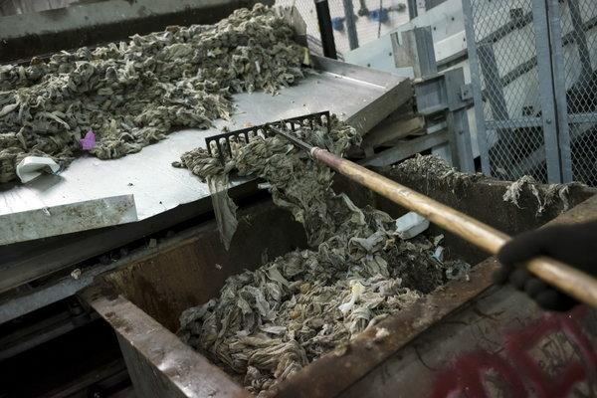
Raking wipes and other waste into a bin for disposal at the Newtown Creek Wastewater Treatment Plant in Brooklyn.CreditCreditKarsten Moran for The New York Times
By Christina Caron
- Aug. 25, 2018

It might seem harmless at first: a thread of dental floss tossed in the toilet, a contact lens swirling down the drain of the bathroom sink. But even the tiniest of items can contaminate waterways.
The small fragments of plastic contact lenses are believed to be contributing to the growing problem of microplastic pollution. Pharmaceuticals, which are also frequently flushed down the drain, have been found in our drinking water, and the consequences are not fully known.
Larger products like wipes and tampons are also clogging sewer systems, resulting in billions of dollars in maintenance and repair costs.
Wondering what’s safe to flush or wash down the drain? We spoke with several wastewater management experts who explained why many frequently disposed items belong in a garbage can, not the toilet.
ADVERTISEMENT

Disposable wipes
Many wipes claim on their packaging to be “flushable,” but almost all of them contain rayon or viscose, said Rob Villée, executive director of the Plainfield Area Regional Sewerage Authority in Middlesex, N.J.
“Unfortunately, the natural water bodies these get into do not have the heat or micro-organism levels to effectively degrade these,” he added. “That is why we see rayon accumulating in the oceans.”
While toilet paper will break down in anywhere from a minute to four minutes, wipes take at least six hours to disintegrate, Mr. Villée said.
Furthermore, the pumps at collection systems that move waste downstream to treatment plants cannot tear them apart.
“We see pumps that are designed to pump up to half a million gallons a day clogging,” Mr. Villée said. Now that wipes are used around the world, he added, “it’s a problem internationally.”

Dental floss
Dental floss, which is usually made of nylon or Teflon, should also stay out of the toilet.
“It seems like, ‘Oh, it’s just a little string,’ but it tends to wrap things up,” Mr. Villée said. “It’ll collect other things and make kind of a big wad of stuff. It’s incredibly strong.”

Contact lenses
When contact lenses are flushed down the toilet or washed down the sink, they do not biodegrade easily. As a result, they may make their way into surface water, causing environmental damage, new research has shown.
[The science of why contact lenses may have a dark side if they are improperly disposed]
The lenses are also impervious to the bacteria that break down biological waste at treatment plants. When researchers at Arizona State University submerged contacts in chambers with the bacteria, they found that the lenses appeared intact seven days later.
“We discourage any kind of plastics because it can make its way through a treatment plant and end up in the receiving water,” said Vincent Sapienza, the commissioner of the New York City Department of Environmental Protection.
Contact lenses “have densities similar to water, so they don’t readily float or sink at wastewater treatment plants,” he added, which means they are not captured and removed at the plant.

Tampons
It is often assumed that tampons can be flushed down the toilet, in part because they are so small. But their absorbent materials, including the string, do not break down easily: They cannot be processed by wastewater treatment centers, and can damage septic systems.
ADVERTISEMENT
Kotex, Playtex and Tampax advise women to throw them away instead.
“It’s best to simply wrap a used tampon in toilet paper and toss it in the garbage or, if you’re in a public washroom, place it in the waste receptacle for feminine hygiene products,” Playtex says on its website.

Medications
Wastewater treatment plants are not designed to filter out pharmaceuticals, so drugs that are disposed of in the toilet or the sink drain end up entering streams, rivers and lakes.
The first major study to document this, conducted by the United States Geological Survey, found low levels of organic wastewater compounds, including prescription and nonprescription drugs and hormones, in 139 streams across the United States during 1999 and 2000. One or more of these chemicals were found in 80 percent of the streams sampled.
A more recent study, which sampled water from 25 drinking-water treatment plants in the United States, found that some pharmaceuticals persisted despite water treatment processes.
The technology that would be required to remove pharmaceuticals from the water at treatment plants is cost-prohibitive, said Ed Gottlieb, the industrial pretreatment coordinator at the Ithaca Area Wastewater Treatment Facility. It is far cheaper to use take-back programs that collect unused medications before they enter the water supply, he added, because those cost only $2 to $5 for each pound of medication collected.
During its nationwide take-back event in April, the Drug Enforcement Administration collected 474.5 tons of pharmaceuticals. The next National Prescription Drug Take Back Day is Oct. 27.
“The amount of pounds they collect is phenomenal,” Mr. Gottlieb said. “It’s huge. And yet there are studies done that show only a very small percentage of what’s out there is being collected.”
ADVERTISEMENT

Kitty litter
Kitty litter will not dissolve in water and can create clogs, even if it is labeled flushable.
Gene Weingarten, a syndicated columnist, described what happenedwhen he flushed a small amount of cat litter down his daughter’s toilet last year.
“Cat litter is a preternaturally absorptive substance, apparently designed to expand to roughly 60,000 times its original volume in some horrible malignant process like cancer, only worse,” he wrote. “Molly’s toilet resembled one of those baking-soda-and-vinegar volcanoes the dumb kids in middle school made every year for science fairs.”

Condoms
Condoms should never be flushed.
“I’ve heard condoms called sewer lilies because they fill with air or gas and float to the top,” said Cynthia Finley, the director of regulatory affairs at the National Association of Clean Water Agencies.
“As a society, I think we’ve become more germophobic,” she said, adding that there is a tendency to want to flush anything that has bodily fluids. But wastewater treatment plants are not designed to handle anything except for human waste and toilet paper, she said.

Facial tissues, paper towels and cotton swabs
Facial tissues might seem safe to flush because they look so much like toilet paper. But unlike toilet paper, facial tissues have been treated with a chemical binder that takes time to release and break apart when flushed, Ms. Finley said.
Likewise, paper towels and cotton swabs are also formulated to stay intact.

When in doubt, throw it out (in a trash can)
If you’re not sure, follow a simple rule: If it is not human waste or toilet paper, it should not be disposed of in the toilet, Ms. Finley said.
The cost of both drinking water and wastewater go into a water bill, said Mr. Sapienza, the New York environmental official. When cities have to send crews to unclog sewers or, in worst-case scenarios, replace them, the cost is passed down to everyone who gets a water bill, he added.
A YouTube video created by the City of Spokane Department of Wastewater Management showed what happened when items like flushable wipes were agitated in water. The wipes did not disintegrate. Kitty litter remained a sandy wet mass. The dental floss spun and spun.
Will It flush?CreditCreditVideo by cityofspokane
“If you define flushable as ‘Yes, it will go down the toilet,’ then everything here is flushable,” Tracy Stevens, a pretreatment technician, says in the video. If you define it as whether it will make it to the treatment plant, she added, some of the waste will and some will not.
More important, the treatment plants are not equipped to process these products.
If hundreds of thousands of people are flushing those items, “they’re going to cause trouble,” she said.

