Glenn Reynolds: Mars ain't the kind of place to raise your kids. Or is it?
Glenn Harlan Reynolds2:11 p.m. EDT September 24, 2015

Colonizing Mars won't be easy, but we can't let the challenge of exploration stop us.
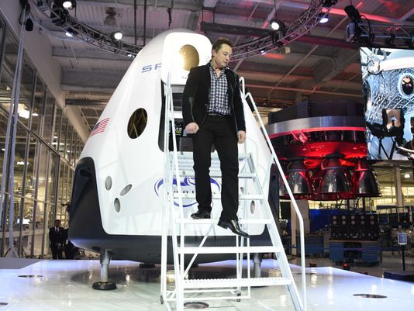
(Photo: Robyn Beck, AFP/Getty Images)
“Let’s not move to Mars,” writes Ed Regis in the New York Times. “First, there is the tedious business of getting there. Using current technology and conventional chemical rockets, a trip to Mars would be a grueling, eight- to nine-month-long nightmare for the crew. Nine months is a long time for any group of people to be traveling in a small, closed, packed spacecraft. ... In addition, there will be persistent mechanical noise and vibration, sleep disturbances, unbearable tedium, trance states, depression, monotonous repetition of meals, clothing, routines, conversations and so on.”
That’s true, of course. It’s also true, as Regis notes, that Mars itself is inhospitable:Cold and dry. In recent years we’ve discovered that Mars has a lot more water than we once thought, but “a lot more water” isn’t the same as “a lot of water.” There’s oxygen in plenty, too, but it’s not freely available in the atmosphere (except as part of carbon dioxide); you have to extract it.
Regis writes in response to a number of recent proposals — most notably from tech-adventurer Elon Musk — to colonize Mars anyway. Musk isn’t the first to make such plans; back in 1988, when I was working for then-senator Al Gore’s presidential campaign, I researched Mars mission architectures that NASA had worked up under President Nixon during the Apollo era. But Musk has unique credentials: He’s a very smart guy, he’s a very rich guy, and he’s already building working spaceships.
So going to Mars raises three questions: (1) Can we do it? (2) Even if we can do it, is it too hard? and (3) Even if we can do it, and it’s not too hard, is it worth the trouble?
The answer to question one is “yes.” We can send people to Mars. (We already send robots to Mars, and have done so so often that it’s barely even newsworthy. In fact, Mars is currently the only known planet inhabited entirely by robots.) The old Nixon-eraapproach would probably have worked.
A much-better plan, the “Mars Direct” mission architecture developed by Robert Zubrinin the 1990s, and spelled out in his popular book, The Case For Mars, would not only work, but would create the infrastructure for colonization from the get-go, and in less than a decade. And it would be much cheaper. (Emailed about Regis’s piece, Zubrin responded: "If he had lived in the Middle Ages, Regis could have made a good income painting dragons on maps.")
The answer to question two depends. in some degree, on what “too hard” means. Regis talks a lot about the personal discomforts involved in a Mars trip, but I suspect that the Mars crew would have things a lot easier than the crews of Columbus andMagellan, who themselves endured months-long voyages with scant rations, cramped space, and high stress. But they also had to climb high above the deck in the middle of a gale to take in sails and risked flogging or hanging for even mild infractions. Exploration is always difficult and uncomfortable. People who like ease and comfort should stay home.
As for question three, well, that’s the easiest. Yes, it’s worth it. If human beings become a multi-planetary species, we become harder to wipe out. If Musk’s ultimate goal of a million colonists living on Mars in a self-sustaining way bears fruit, then even calamities that would wipe out life or civilization on Earth, like a major nuclear war or asteroid impact, will no longer be extinction-level events. That’s a pretty big deal.
But I think there’s an even bigger reason to settle Mars: Earth civilization has become boring and inbred. Back in the 1960s, people talked about the development of a “global village,” but village life can get awfully stagnant, especially when there is nowhere else to go. A Mars society, developing at a distance from Earth and in a different environment, would bring useful diversity to human culture.
So, contrary to Regis, I think a Mars colony would be a great idea. Meanwhile, in reading his column I was reminded of another New York Times piece on the wastefulness and difficulty of space research. It was a 1920 editorial by theTimes chiding Robert Goddard for his foolish interest in rocketry: Everyone knew, theTimes editors wrote, that a rocket couldn’t work in the vacuum of space, as there would be nothing to push against. The Times published a retraction 49 years later in 1969, as men landed on the Moon, commenting: “Further investigation and experimentation have confirmed the findings of Isaac Newton in the 17th century and it is now definitely established that a rocket can function in a vacuum as well as in an atmosphere. The Times regrets the error.”
Will space history repeat itself? I believe that it will.
Glenn Harlan Reynolds, a University of Tennessee law professor, is the author of The New School: How the Information Age Will Save American Education from Itself, and a member of USA TODAY's Board of Contributors.

http://www.usatoday.com/story/opinion/2015/09/24/glenn-reynolds-mars-colonize-explore-musk-nasa-column/72672032/

