How to Win a War on Drugs
Portugal treats addiction as a disease, not a crime.
By NICHOLAS KRISTOF SEPT. 22, 2017

https://www.nytimes.com/2017/09/22/opinion/sunday/portugal-drug-decriminalization.html?rref=collection%2Ftimestopic%2FHeroin&action=click&contentCollection=timestopics&region=stream&module=stream_unit&version=latest&contentPlacement=1&pgtype=collection&_r=0

LISBON — On a broken-down set of steps, a 37-year-old fisherman named Mario mixed heroin and cocaine and carefully prepared a hypodermic needle. “It’s hard to find a vein,” he said, but he finally found one in his forearm and injected himself with the brown liquid. Blood trickled from his arm and pooled on the step, but he was oblivious.
“Are you O.K.?” Rita Lopes, a psychologist working for an outreach program called Crescer, asked him. “You’re not taking too much?” Lopes monitors Portuguese heroin users like Mario, gently encourages them to try to quit and gives them clean hypodermics to prevent the spread of AIDS.
Decades ago, the United States and Portugal both struggled with illicit drugs and took decisive action — in diametrically opposite directions. The U.S. cracked down vigorously, spending billions of dollars incarcerating drug users. In contrast, Portugal undertook a monumental experiment: It decriminalized the use of all drugs in 2001, even heroin and cocaine, and unleashed a major public health campaign to tackle addiction. Ever since in Portugal, drug addiction has been treated more as a medical challenge than as a criminal justice issue.
After more than 15 years, it’s clear which approach worked better. The United States drug policy failed spectacularly, with about as many Americans dying last year of overdoses — around 64,000 — as were killed in the Vietnam, Afghanistan and Iraq Wars combined.
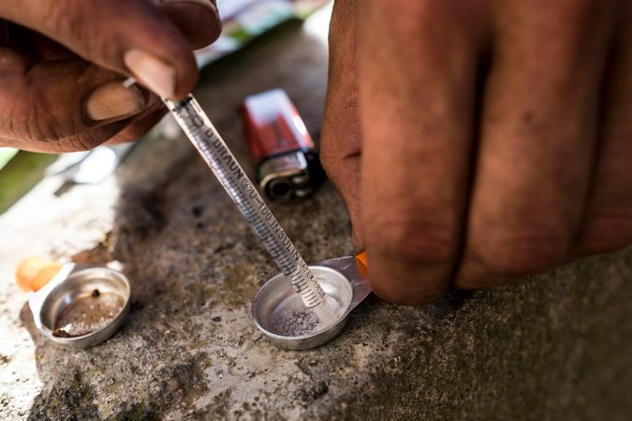
A fisherman named Mario preparing an injection. CreditDaniel Rodrigues for The New York Times
In contrast, Portugal may be winning the war on drugs — by ending it. Today, the Health Ministry estimates that only about 25,000 Portuguese use heroin, down from 100,000 when the policy began.
The number of Portuguese dying from overdoses plunged more than 85 percent before rising a bit in the aftermath of the European economic crisis of recent years. Even so, Portugal’s drug mortality rate is the lowest in Western Europe — one-tenth the rate of Britain or Denmark — and about one-fiftieth the latest number for the U.S.
I came to Portugal to talk with drug dealers, users and public health experts because this nation has become a model for a drug policy that is not only compassionate but also effective.
It’s not a miracle or perfect solution. But if the U.S. could achieve Portugal’s death rate from drugs, we would save one life every 10 minutes. We would save almost as many lives as are now lost to guns and car accidents combined.
Outreach workers, like here in the Casal Ventoso neighborhood, try to persuade drug users to quit or at least to minimize risks. CreditDaniel Rodrigues for The New York Times
This issue is personal to me, because my hometown in rural Oregon has been devastated by methamphetamines and, more recently, by opioids. Classmates have died or had their lives destroyed; my seventh-grade crush is now homeless because of her addictions.
Many people are also coming to Portugal to explore what a smarter, health-driven approach might look like. Delegations from around the world are flying to Lisbon to study what is now referred to as the “Portuguese model.”
“This is the best thing to happen to this country,” Mario Oliveira, 53, a former typesetter who became hooked on heroin 30 years ago, told me as he sipped from a paper cup of methadone supplied by a mobile van. The vans, a crucial link in Portugal’s public health efforts, cruise Lisbon’s streets every day of the year and supply users with free methadone, an opioid substitute, to stabilize their lives and enable them to hold jobs.
Methadone and other drug treatment programs also exist in the U.S., but are often expensive or difficult to access. The result is that only 10 percent of Americans struggling with addiction get treatment; in Portugal, treatment is standard.
Photo
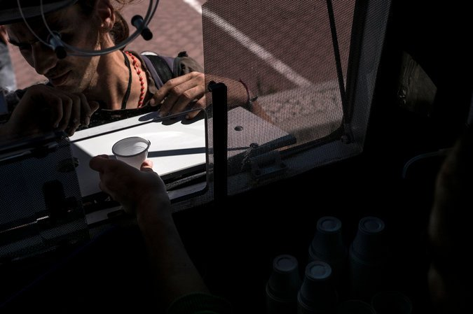
A van distributing methadone, an opioid substitute, in the Lumiar neighborhood. CreditDaniel Rodrigues for The New York Times
“If I couldn’t come here, I don’t know if I’d still be alive,” Oliveira told me. He said that he used to steal to support his habit but is now getting his life under control. Two weeks ago, he began reducing his dose of methadone, and he hopes to wean himself off opioids completely.
Yet Portugal’s approach is no magic wand.
“I’m homeless and jobless and addicted again,” Miguel Fonseca, a 39-year-old electrical mechanic, said as he held a lighter under a sheet of tin foil to turn a pinch of heroin powder into fumes that he smoked to get high. He spends about $100 a day on his habit, and in the past sometimes has turned to theft to support it.
Less than 100 feet away, Mario, the fisherman I began this story with, was injecting himself with heroin and cocaine, and showing little interest in Lopes’s health outreach. He assured her that he wasn’t overdosing, and he scoffed at the idea of methadone as an alternative to heroin.
Mario told me that he had started with heroin at age 14 (another man I met had started at age 11), and used it during the two years he worked as a fisherman in Massachusetts. “Portuguese heroin isn’t as high quality as American heroin,” he complained. He then reached for a pipe and began to smoke cocaine.
Public health workers like Lopes may never be able to get Mario to give up drugs, but she can help keep him alive. Seeing Mario, his blood spattered on the steps from his constant injections, tottering off to get more drugs, it was clear that the Portuguese model isn’t as effective as we might hope — but it occurred to me that in America, Mario might well be dead.
Portugal switched to its health focus under the leadership of a socialist prime minister named António Guterres — and if the name sounds familiar, it’s because he’s now the United Nations secretary general. The new approach was a gamble. “We were facing a devastating situation, so we had nothing to lose,” recalled João Castel-Branco Goulão, a public health expert and the architect of the policy (“our national hero,” as one Portuguese cabinet minister told me).
So let’s be clear on what Portugal did and didn’t do. First, it didn’t change laws on drug trafficking: Dealers still go to prison. And it didn’t quite legalize drug use, but rather made the purchase or possession of small quantities (up to a 10-day supply) not a crime but an administrative offense, like a traffic ticket.
Offenders are summoned to a “Dissuasion Commission” hearing — an informal meeting at a conference table with social workers who try to prevent a casual user from becoming addicted.
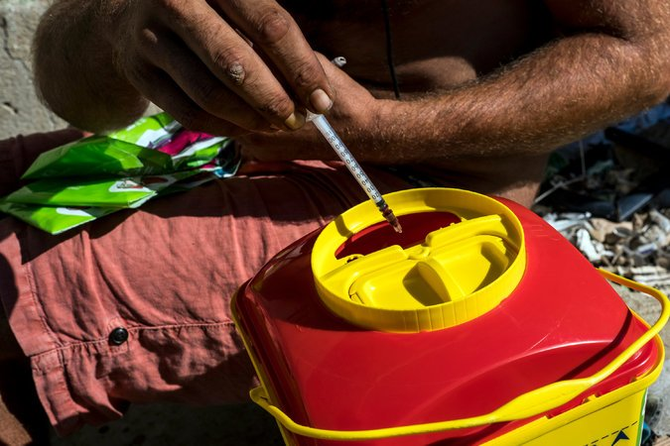
Hypodermic kits are distributed by outreach workers and used syringes are collected for safe disposal and to prevent sharing. CreditDaniel Rodrigues for The New York Times
“How long have you been using?” Nuno Capaz, a sociologist and member of the Dissuasion Commission in Lisbon, asked a 26-year-old factory worker caught with hashish. They chatted, with Capaz trying to figure out if the young man was in danger of taking up harder drugs. The dissuasion board can fine offenders, but that’s rare. Mostly the strategy is to intervene with counseling or other assistance before an offender becomes addicted.
“My main concern is the health of the person,” Capaz explained afterward. “Our approach is much closer to that of a medical doctor than to a court of law.”
The public health approach arises from an increasingly common view worldwide that addiction is a chronic disease, perhaps comparable to diabetes, and thus requires medical care rather than punishment. After all, we don’t just tell diabetics, Get over it.
My sense from observing the hearings and talking to users is that the Dissuasion Commission isn’t terribly effective at dissuading. How successful could a 15-minute session be? Then again, criminal sanctions also seem ineffective at discouraging drug use: When scholars look at the impact of crackdowns, they find there’s typically little impact.
In the first year or so of decriminalization in Portugal, there did seem to be the increase in drug use that critics had predicted. But although the Portuguese model is often described simply as decriminalization, perhaps the more important part is a public health initiative to treat addiction and discourage narcotics use. My take is that decriminalization on its own might have led to a modest increase in the use of hard drugs, but that this was swamped by public health efforts that led to an overall decline.
Portugal introduced targeted messaging to particular groups — prostitutes, Ukrainians, high school dropouts, and so on. The Health Ministry dispatched workers into the most drug-infested neighborhoods to pass out needles and urge users to try methadone. At big concerts or similar gatherings, the Health Ministry sometimes authorizes the testing of users’ drugs to advise them if they are safe, and then the return of the stash. Decriminalization makes all this easier, because people no longer fear arrest.
So how effective are the methadone vans and prevention campaigns? I thought I’d ask some real experts: drug dealers.
“There are fewer customers now,” complained one heroin dealer in the gritty Lumiar neighborhood. Another, Joaquim Farinha, 55, was skeptical that methadone was costing him much business. “Business is still pretty good,” he said, interrupting the interview to make a sale to a middle-aged woman.
(Portugal’s drug market is relatively nonviolent and relaxed partly because of another factor: Handguns are tightly controlled.)
On balance, the evidence is that drug use stabilized or declined since Portugal changed approaches, particularly for heroin. In polls, the proportion of 15- to 24-year-olds who saythat they have used illicit drugs in the last month dropped by almost half since decriminalization.
Decriminalization also made it easier to fight infectious diseases and treat overdoses. In the U.S., people are sometimes reluctant to call 911 after a friend overdoses for fear of an arrest; that’s not a risk in Portugal. In 1999, Portugal had the highest rate of drug-related AIDS in the European Union; since then, H.I.V. diagnoses attributed to injections have fallen by more than 90 percent and Portugal is no longer at the high end in Europe.
One crucial mistake that Portugal did not make was to follow the United States in adopting prescription opioid painkillers for routine use. Adalberto Campos Fernandes, the health minister, said that Portuguese doctors resisted overprescribing and that regulators also stood in the way.
Photo
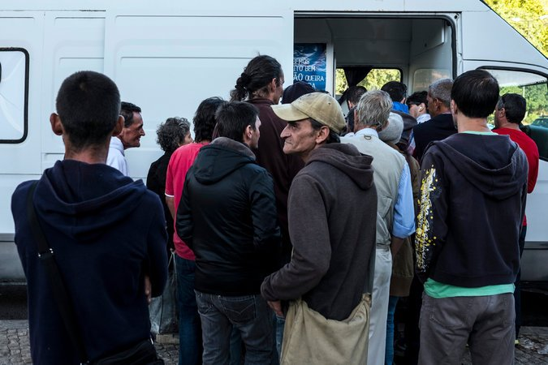
Recovering drug users receive daily doses of methadone from vans that cruise Lisbon streets.CreditDaniel Rodrigues for The New York Times
Another factor that has benefited Portugal: The economy has grown and there is a robust social fabric and safety net, so fewer people self-medicate with drugs. Anne Case and Angus Deaton of Princeton University have chronicled the rise of “deaths of despair” and argue that opioid use in America in part reflects a long-term decline in well-paying jobs for those with a high school education or less.
Portugal initially was scolded around the world for its experiment, as a weak link in the war on drugs, but today it’s hailed as a model. The World Health Organization and American Public Health Association have both praised decriminalization and a public health focus, as has the Global Commission on Drug Policy.
One attraction of the Portuguese approach is that it’s incomparably cheaper to treat people than to jail them. The Health Ministry spends less than $10 per citizen per year on its successful drug policy. Meanwhile, the U.S. has spent some $10,000 per household (more than $1 trillion) over the decades on a failed drug policy that results in more than 1,000 deaths each week.
I’ve been apprehensive of decriminalizing hard drugs for fear of increasing addiction. Portugal changed my mind, and its policy seems fundamentally humane and lifesaving. Yet let’s also be realistic about what is possible: Portugal’s approach works better than America’s, but nothing succeeds as well as we might hope.
The hilly Casal Ventoso neighborhood of Lisbon was ground zero for heroin in Lisbon 15 years ago, “a wall of death,” remembered Paulo Brito, 55, who has been using heroin since he was 15.
Brito weaned himself off drugs with the help of health workers and remained “clean” for 10 years — but relapsed a year ago, and I met him in today’s Casal Ventoso. There are fewer overdoses now, but it is still littered with hypodermic packages and other detritus of narcotics, as well as a pall of sadness.
“I’ve hit rock bottom,” Brito told me despairingly. “I’m losing the person I most love in the world.”
His girlfriend, Teresa, is begging him to give up heroin. He wants to choose her; he fervently wants to quit. But he doesn’t know if he can, and he teared up as he said, “It’s like entering a boxing ring and facing Mike Tyson.”
Yet for all his suffering, Brito lives, because he’s Portuguese. The lesson that Portugal offers the world is that while we can’t eradicate heroin, it’s possible to save the lives of drug users — if we’re willing to treat them not as criminals but as sick, suffering human beings who need helping hands, not handcuffs.

